KILLARNEY MEATS  CUSTOM CUTTING & PROCESSING RATES • 2026 | 
Service | Rate | Billing / minimum
BASIC LIVESTOCK SERVICES
Beef butchering | $0.35/lb | Hot dressed weight
Beef environmental fee | $0.40/lb | Hot dressed weight
Beef processing | $0.90/lb | Hot dressed weight
Beef complete basic service | $1.65/lb | All three charges above
Pork butchering | $0.35/lb | Hot dressed weight
Pork environmental fee | $0.40/lb | Hot dressed weight
Pork processing | $0.90/lb | Hot dressed weight
Pork complete basic service | $1.65/lb | All three charges above
Lamb/goat butchering | $50/head | Per animal
Lamb/goat environmental fee | $20/head | Per animal
Lamb/goat processing | $80/head | Per animal
Lamb/goat complete basic service | $150/head | All three charges above
Primal processing — all species | $0.65/lb | Carcass weight; replaces processing
CUTTING, GRINDING & PACKAGING
Grinding and packaging | $0.55/lb | Finished weight; no minimum
Grinding fat | $0.55/lb | Finished weight
Organ processing | $0.90/lb | Finished weight
Additional organ grinding | $0.55/lb | Added to organ processing
Stew meat | $0.85/lb | 15 lb minimum per animal
Kabob meat | $0.85/lb | 15 lb minimum per animal
Stir-fry meat | $1.25/lb | 15 lb minimum per animal
Minute steak | $1.50/lb | 15 lb minimum
Slicing services | $1.00/lb | Jerky meat (15 lb min.), side pork or roast beef
Marrow/cut and packaged bones | $1.75/lb | Finished weight
BONES, PET FOOD & ORGANS
Boxed bones | $10/box | Bulk, uncut bones
Dog-food salvage | $1.00/lb | Take-home weight
Organs saved for pet food | $10/box | Per box
WILD GAME
Average deer processing | $175/head | Further processing is extra
Moose/elk processing | $1.15/lb | Incoming weight; further processing extra
Wild-game grinding | $0.55/lb | Finished weight
Slaughter-only orders are charged butchering and environmental fees. Standard processing is replaced by the primal rate when meat is taken home as primals.
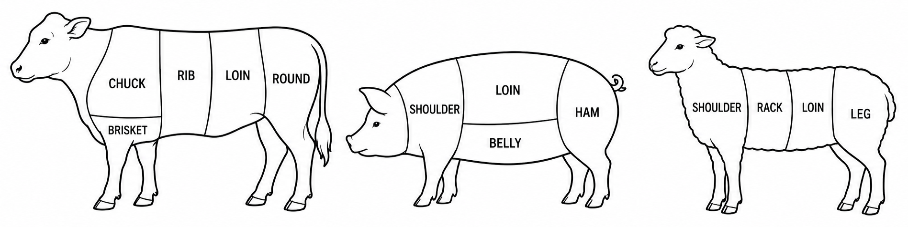

KILLARNEY MEATS
FURTHER PROCESSING & ADDITIONAL SERVICES • 2026
Service | Rate | Billing / minimum
PATTIES
Hamburger patties | $3.25/lb | Finished weight; 15 lb raw minimum
Gluten-free hamburger patties | $3.50/lb | Finished weight; 15 lb raw minimum
Breakfast sausage patties | $4.50/lb | Finished weight; 15 lb raw minimum
Smoked farmer sausage patties | $5.50/lb | Finished weight; 15 lb raw minimum
SAUSAGE & COILS
Fresh sausage | $3.50/lb | Finished weight; 15 lb raw per flavour
Breakfast sausage | $3.75/lb | Finished weight; 15 lb raw per flavour
Smoked sausage | $5.00/lb | Finished weight; 15 lb raw per flavour
Taco meat | $3.50/lb | Finished weight; 15 lb raw minimum
Garlic, kielbasa, ham or pepperoni coil/chub | $7.00/lb | Finished weight; 15 lb minimum
Shop meat added to sausage | Pork $3.50/lb • Beef $6.99/lb | Raw added weight; processing extra
HAM, BACON & SMOKED SPECIALTIES
Ham | $3.25/lb | Finished take-home weight
Un-sliced slab bacon | $3.25/lb | Finished take-home weight
Sliced bacon | $4.25/lb | Finished take-home weight
Shoulder bacon / beef bacon | Bacon rate | Based on sliced or unsliced finish
Smoked roast beef | $6.00/lb | Finished weight; 20 lb raw minimum
Cryovac packaging | $0.50/bag | Charged separately where required
JERKY
Original / honey-garlic jerky sticks | $9.50/lb | Finished weight; 15 lb raw minimum
Pepperoni sticks | $10.75/lb | Finished weight; 15 lb raw minimum
Muscle jerky — original or teriyaki | $20.00/lb | Finished weight; 15 lb raw minimum
ADDITIONAL CHARGES
Additional hanging after 14 days | $75/week | Per additional week
Condemned carcass disposal | Beef $200 • Pig $125 • Lamb/goat $75 | Per condemned carcass
Customer PLU services | Setup $150 • Annual $100 | Per customer
Animal labeling | Beef $70 • Pork $35 • Lamb/goat $15 | Per animal

PROCESSING SUPPLIES FOR SALE
Stretch netting — #18, 50 m | $50.00/roll | Pickle cure | $2.88/100 g • $28.75/kg
Butcher twine | $22.25/roll | GF 260 fresh-sausage binder | $0.98/100 g • $9.75/kg
18" wrapping paper — 900 ft | $67.50/roll | Italian sausage binder | $1.43/100 g • $14.25/kg
1 lb hamburger bags — 1,000 | $130/box • $0.25/bag | Honey-garlic sausage binder | $2.58/100 g • $25.75/kg
2 lb hamburger bags — 1,000 | $145/box • $0.25/bag | Gum tape | $16.25/roll
Wild-game bags — 2,000 | $280/box • $0.25/bag | Burger-bag tape | $4.20/roll
Binders and cures are weighed and charged proportionally. Specialty ingredients may be charged separately.

